# **DATA CLEANING**

Google Colab file: <https://colab.research.google.com/drive/1VltiIJjsm_WZctniclAJSNdanRjIwKmn?usp=sharing>

# **DESCRIPTIVE ANALYTICS**

* Total Quantity of the products sold:



* Number of Unique Products that are sold:





* Trend of sales by Month from December 2010 to December 2011:

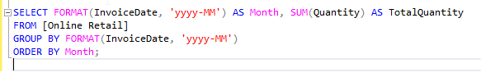

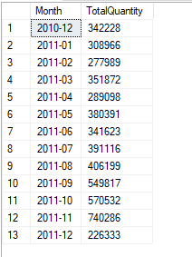

* Most frequently sold item:

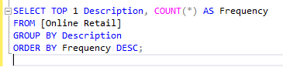

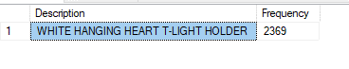

* Order frequency of the customer:

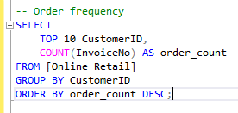

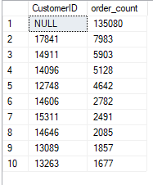

* Order recency by the customer:

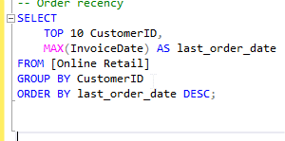

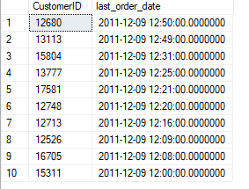

* Average order value of customers:

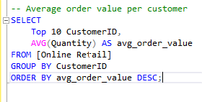

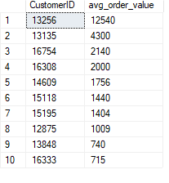

* Product sold by Country.

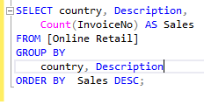

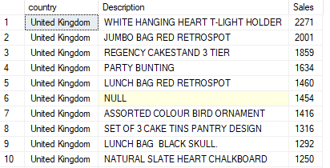

* Count of Customer by Country.

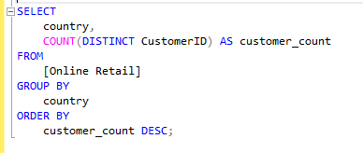

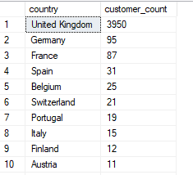

* Average Order Value (AOV) by Country:

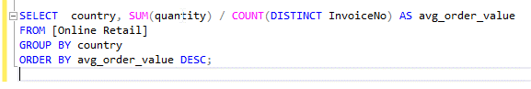

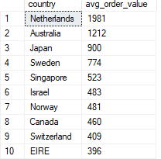

* Customer churn rate by country:

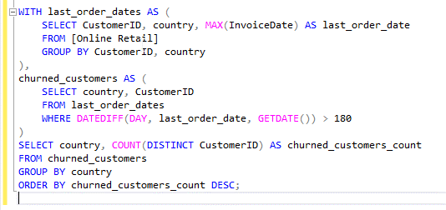

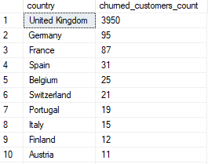

* Top 10 countries by the number of Transactions:

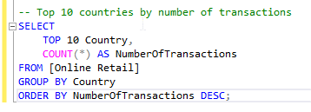

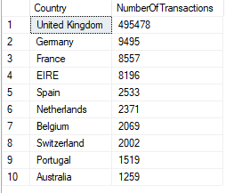

* The number of Stocks sold:

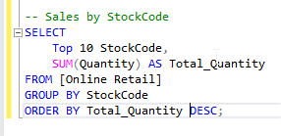

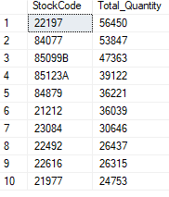

# **STATISTICAL ANALYSICS**

**RFM Analysis (Recency, Frequency, Monetary)**

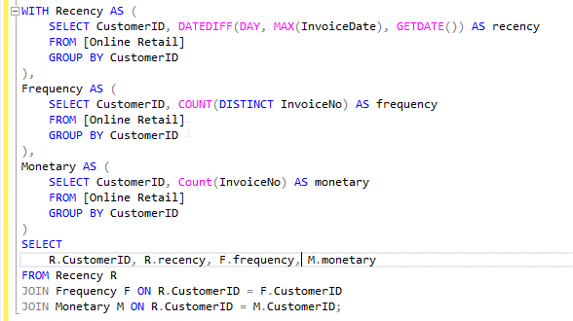

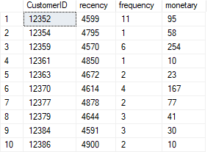

**Product Performance Analysis**

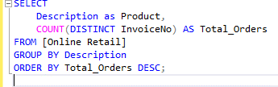

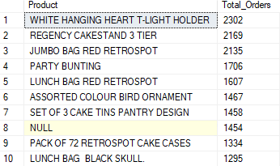

**Cohort Analysis**

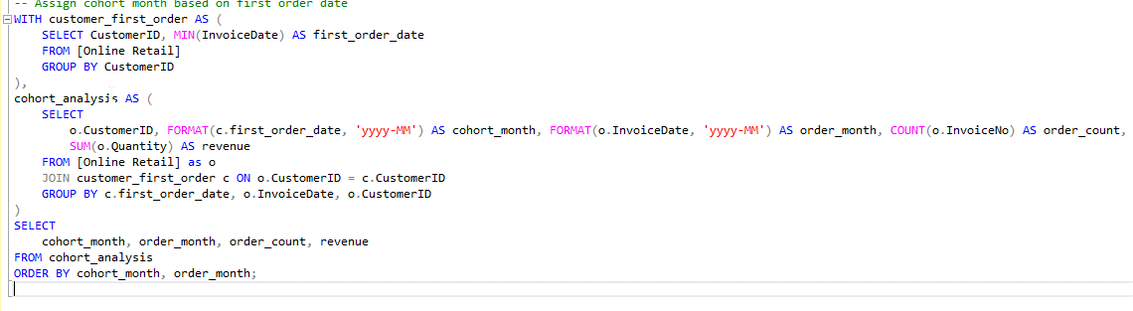

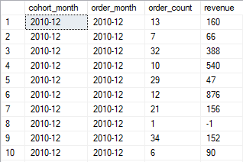

**Customer Churn Analysis**

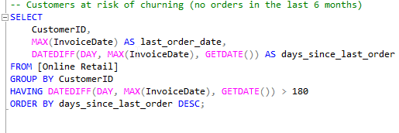

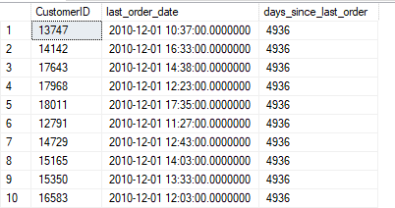

**Customer Lifespan Value**

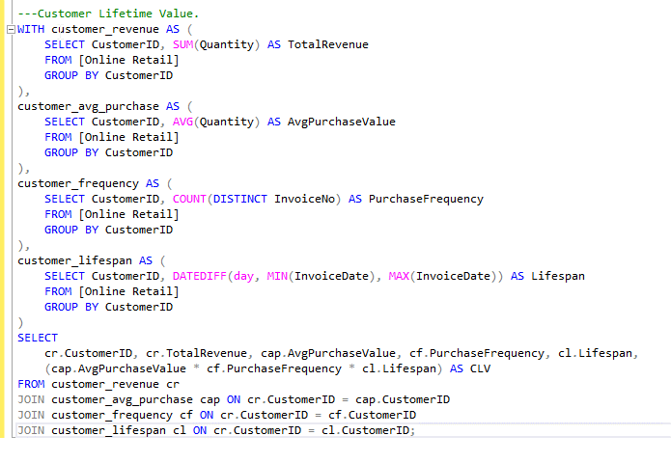

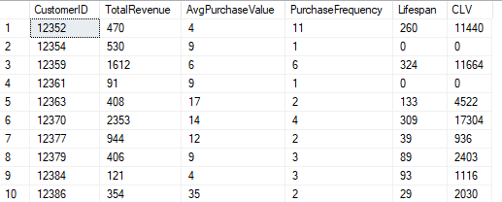

# **FINDINGS**

1. Summing up the Total Quantity of all the products sold by the company which turns out to be **5176450**.
2. The Unique Number of products sold by the company is **3958**.
3. The Trend of Sales for each month of the year which gives the insights when the sales of company **increased** and when it is **decreased**.
4. The most frequently sold item in the inventory which is **White Hanging Heart T-Light Holder**.
5. Showing the **Frequency of Orders** bought by the customer. The null value of CustomerID at index 1 is because the row 1 is added while cleaning to match the number of rows in duplicate table.
6. Which Customer made a purchase recently and the frequency of their **purchases**.
7. The average order value of the customers which shows how much orders a customer made.
8. The number and names of Products sold based on the country.
9. The number of customers in each country.
10. Average order value based on the country which has Netherlands on top.
11. The customer churn rate tells us the number of customers that churned based on the country.
12. The top 10 countries based on the sales made in each country.
13. The rate of sales based on the StockCode of the products which tells us which Stockcode is making more sales.
14. The **RFM (Recency, Frequency, Monetary)** is calculated which shows the last time the customer bought the product and of how much frequency he bought the product which helps in segmenting customers in different categories.
15. The **Product Performance Analysis** shows the most sold products.
16. **Cohort Analysis** on customer which analyze customer retention and behavior over the time.
17. Based on frequency of orders and the last date on which the order is placed, check whether the customer is most likely to churn or not.
18. Calculating customer lifespan value which gives us insights about the customer loyalty and how more likely the customer is to buy our products.

# **ACTIONABLE INSIGHTS AND RECOMMENDATION**

* **Product Strategy:** Focus on high revenue products which are more sold.
* **Customer Segmentation:** Segment the customers based on demographics and behavior of purchasing.
* **Customer Retention:** Build loyalty programs, provide discounts.
* **Product Expansion:** Focus on expanding the range of the high selling products.
* **Geographical Expansion:** Identify high-potential regions for market expansion based on sales of the products.
* **Personalized Marketing:** Use RFM to deliver personalized marketing messages and offers to the potential customers.
* **Churn Prevention:** Reach out to customers at risk of churning with special offers.
* **Localization:** Customize marketing campaigns and product offerings based on regional preferences.
* **Target Low-Revenue Segments**: Implement strategies to increase spending from low-revenue customers.

# **FORMULATING HYPOTHESIS**

* To increase the customer lifetime value, a loyalty program should be implemented which will benefit the regular customers and retain the new ones.
* During peak months of sales (which are August, September, October and November), promotion of sold products and discounts will significantly boost the sales.
* Combine Top-selling products with Slow-moving products and provide complimentary with Top-selling products will eventually increase the sales.
* Build Strategies to retain customers which are more likely to churn.